Design Document Visual Feedback Feature

**April 4th 2019**

**OBJECTIVE**

Implement additional features into the Jammming App to provide visual feedback to the end-user whenever data is added from pane to pane and from the app to Spotify.

**BACKGROUND**

Jammming currently provides visual feedback whenever a track is removed from the Playlist pane, however similar functionality is absent from the Results Pane and one the Playlist whenever a playlist is saved to Spotify. The search results from Spotify provide a large amount of information per query and so it can be easy to lose one’s place when adding tracks into a playlist or saving playlist into Spotify. If these issues are not address it can lead to frustration for the end-user and ultimately abandonment of the app as the information flow be perceived to be one-way in the app’s current state.

**TECHNICAL DESIGN**

**Visual Feedback on the Search Results Pane.**

A new array would need to be created to be used by the .addTrack() method. This additional array would be created via a .filter() iterator whenever the end-user clicks on the ‘+’ anchor. The callback function on the .filter() method will use the track.id from the track parameter already passed into the .addTrack() method to filter on the all track.id **not** matching the element on the iterator. The resulting array will therefore contain only those tracks not added into the playlist by the user. Lastly the App state should be set to the new array. This then display only those tracks in the Results pane which were not added into the Playlist pane.

Current Functionality

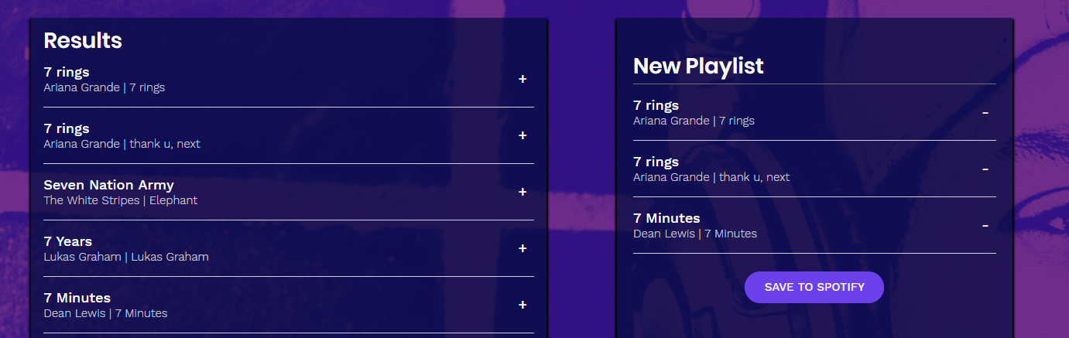

New Functionality

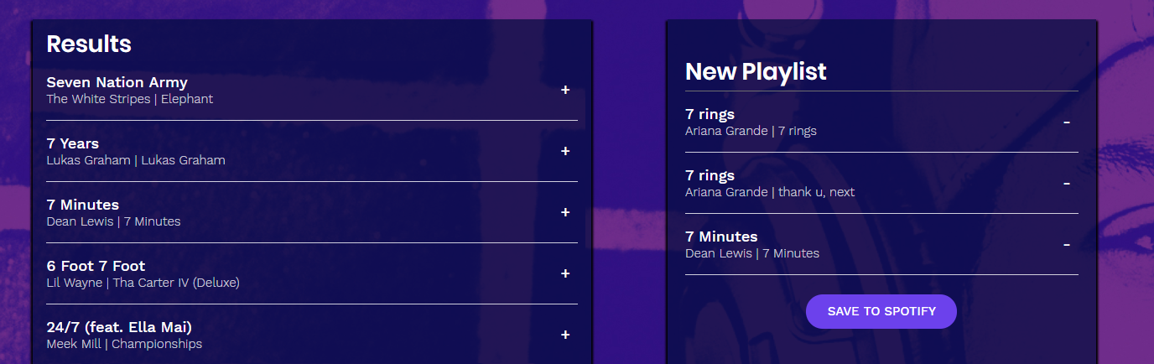

**Visual Feedback on the Playlist Pane.**

The API call to Spotify would need to be modified and the search parameters would need to be expanded to include information on whether the current playlist was saved to Spotify. Once a playlist is added to Spotify, Jammming will need to store the playlist Spotify ID (i.e. 6rqhFgbbKwnb9MLmUQDhG6) in a new array in order to keep track of the playlists added into Spotify during any particular session. The new array would also serve to populate the Playlist pane with the playlist added to Spotify as a visual indicator that a playlist now lives in the Spotify account. However those playlists would be read-only in the Jammming app.

Current Functionality

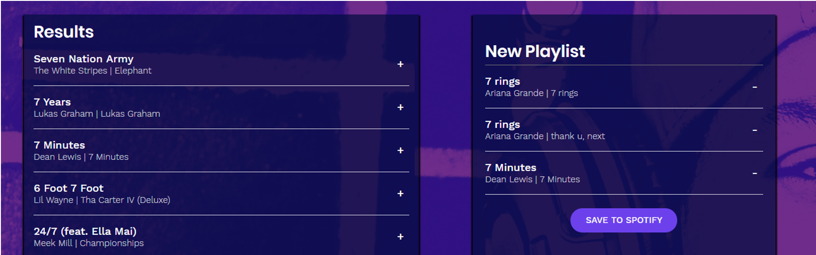

New Functionality

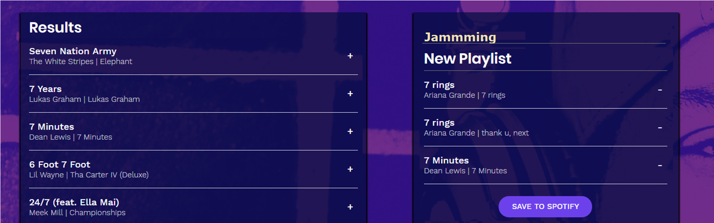

**CAVEATS**

The visual feedback on the Search Results Pane may require that the amount of data returned on the search query be expanded if the user adds most tracks from a single search query. Which will result in the Search Pane decreasing in size, visually as the Playlist pane increases in size. Additional functionality may be added to the Search Results pane to continually provide search results as the end-user add tracks from this pane into the Playlist pane. Adding visual feedback on the Playlist pane may prompt end-users for additional needs in the app such as: ability to expand playlist and view tracks, remove/add tracks from playlist, remove playlist, etc. The additional visual feedback feature will increase the end-user expectations on more functionality on the app. Which in turn may increase the budget and scope of the project and work required in order to implement the new functionality.